# 

# xxviii. let these be / your secret works…

xx. let these be / your secret works… 1

the distance between two whispers 2

let these be / your secret works 4

ii. meekness and myrrh 7

ii. the old thirst for verse 8

an image of the all in all 10

[from moleskine #5 sept. 2010] 12

a failure of tongue 14

12/24/10 16

too close. too near to see. 12/27/10 17

tiny human love, measured in centimeters 18

moleskine #6 24

[from moleskine #2 (during his 698?)]



[heavy love]

[weezer- you’ll always be my girlfriend]

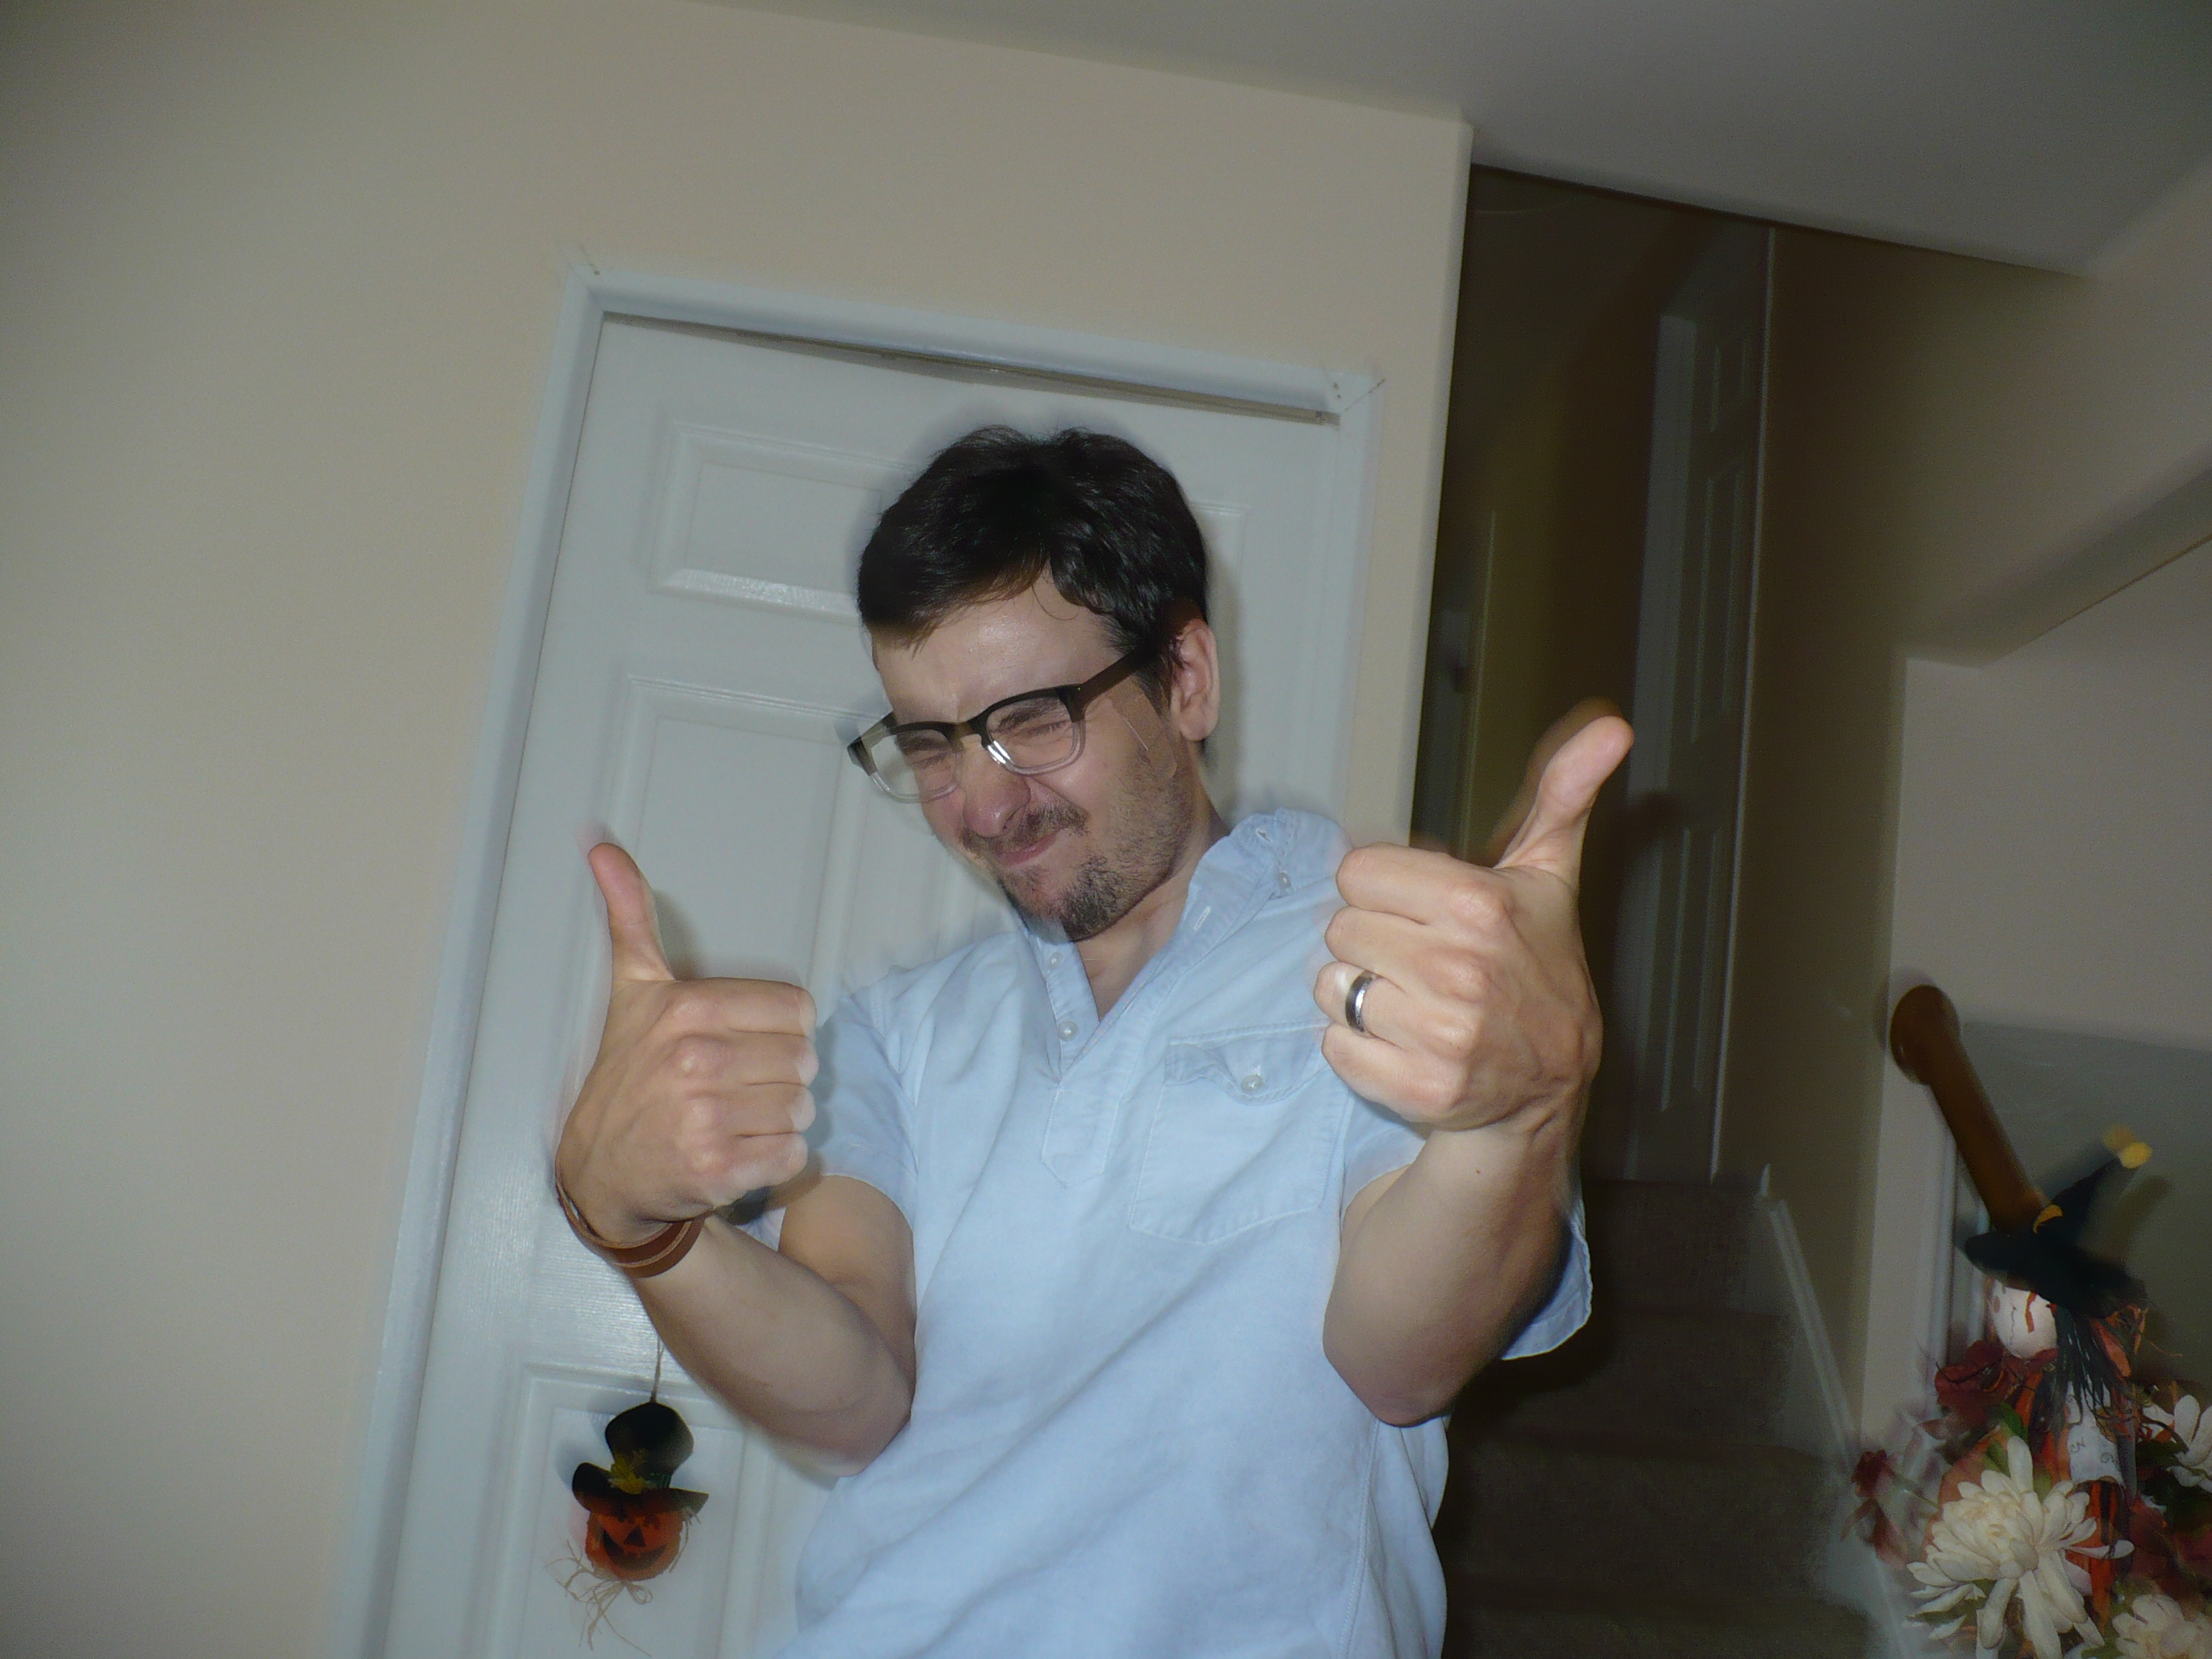 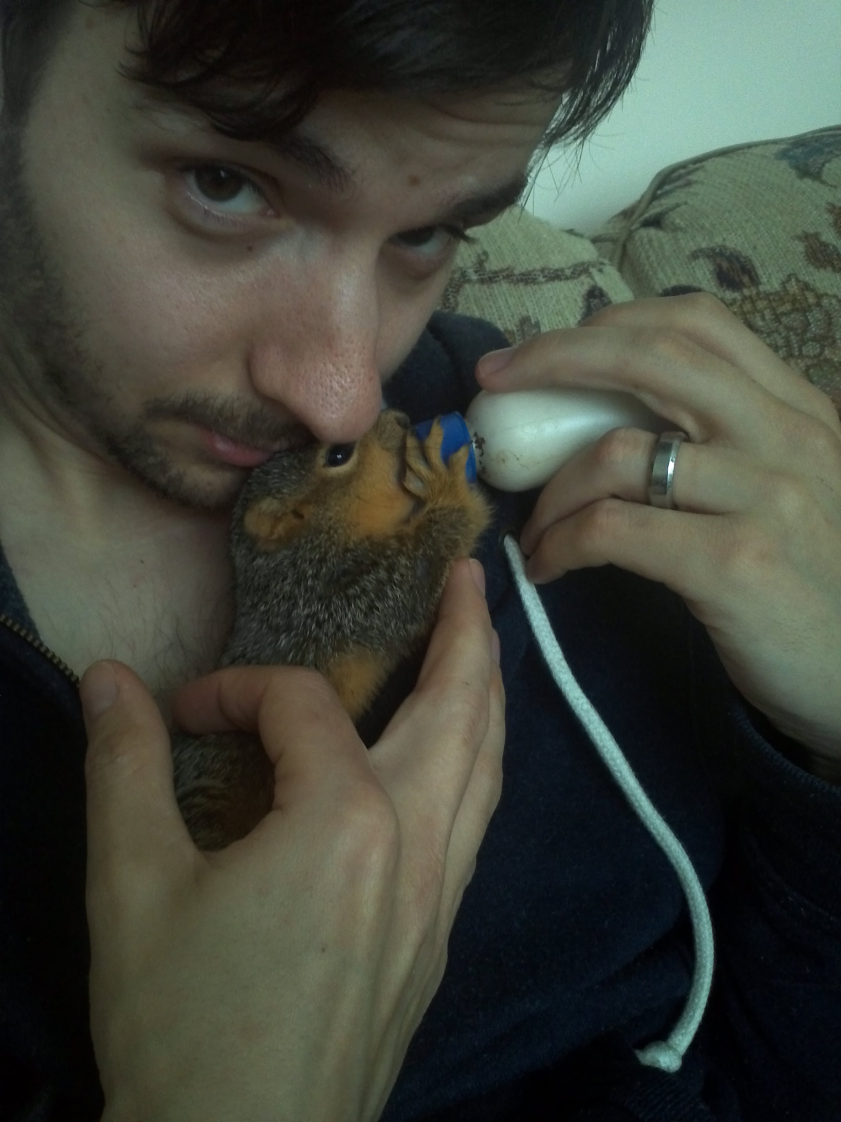

*

## the distance between two whispers

6/26/09

so what is this place? i went back yesterday and read my first book of poems, written

between the 15th and 18th years of life, and saw that it is true: my voice

has succumbed to the gurgle of / blood that stinks

in the throat of the dying man – and not a beautiful

gurgle, not a seed-

bright blood, not a haggard

cough that

spatters

blood

on the snow bank, not purple-

white seeds of blood, the song

of a life that hibernates, that dies

to live that dies to live

and sleeps in the covering snow and dies and dies and dies

and in the spring takes root to bear

an infinite golden city – no. it is not

that kind of blood, my whisper.

and this is a banality: the poet

cannot write. or rather the poet – more horrible still – *chooses* not to write. some stinging (singing)

thing in the throat, some

ache of stinking hope.

so put a trach in this purple

bruise, cut a path for air to the bleeding

lungs – put the tube in, dammit – put the tube in now or

die – cut through the scar-tissue tear

away this veil of scars, tear it away this

scrim of tissue – fuck

you tear it

away or

die –

listen: i have never been

a genius, but i have heard

the music!

all the games of

language break

before this

need: to touch the world! to drink in life,

and love! to dissolve in the wind of life and feel it

cutting me to ribbons!

to bleed and die and return

with the silent, silly message – love! the light so small,

and useless, piercing

the skin of night:

your bodies lives your

faces bathed

by the ugly glow:

the world has no place for me and you

have no place for my awkward

words, these sickly

pearls of greatest price.

so i will whisper here and hide it away, hide away the breach

in the thick-dark

body mass, the miraculous

spark reaching out to

touch, the voice that bridges the distance

between a body,

here, and a

body, there, or a

whisper, here, and a

whisper, there.

can you

call back? can you return

from a thousand years

or further?

oh who will cross

the distance between two whispers?

[from moleskine #6]

## let these be / your secret works

1/31/09

what wild shifts in mood. Cigarettes don't help. here's the dilemma: the dilemma. you must believe in writing, in its power to redeem, in order to write poetry that redeems. words have power, the Logos lives hidden in the poem, the poem brings him to presence. but i no longer believe in the power of poems, of words to stretch beyond expression, or to redeem. there's only One. wh what--does writing end in Him? how could that be?

there must be another way.

words, there is some

desperate

gasping, panting

in your powers, there is some

spark of the infinite, some

dust mote

of the divine. or no, no--

the divine is outside of you, but i remember

beauty

in your presence. that sad

sinking feeling

that eludes the poem

is the sense

that beauty

will not

be mine. that i cannot

taste it

through your power (although i

have, i have--but it's not

the beautiful

forever, just a taste

that tortures all the more

than nothing).

so poetry then these

words these

empty canisters

meaning nothing or at least

in comparison w/

your everything,

nothing--are the lining

inside

an ache, a longing

that lives

in the gap; a sighing knell or

startled gasp

in longing's throat, a witness

to the presence

of the impossible

that points the way

but never arrives.

can you live

inside of achingness? the answer,

i think, is no--i have

broken apart. i've lost

too much, my heart

has collapsed

on the table, sick

w/ longing + deathly

afraid

of the dark and

hungry, aching,

hungry--

i have no bright words

and no shining poem

about beauty.

the audience lives

inside my voice oh how

oh how i hate them, even though

i need them,

like a whore.

there is that poem

that never was, that reaches

across the impossible distance.

that ignites the fire.

that doesn't put out

the smoking

ember. there is that

Word

that lives forever, and that's come

to save lives,

not destroy them.

why don't you make a commitment

to let these silent poems and secret words blossom

here in the dark, where no one hears and no one

reads but your father, until the book is filled,

or for forever or until the father says,

"it's time." let these secret words live

in the shadows and grow there

dark

and rich. blood-soil, bone-soil,

soil of broken

speech. this is my book

of secret works

and of thoughts that grow

in darkness, and will become

more achingly beautiful

than anything

that came before. these will be

as perfect words

that i will accomplish

in secret, and my father who sees in secret

will know, and hear, and keep them close

to his longing.

these words that bear

in barrenness, these flowers

of the moon.

let it be a secret thing

that leaks out like the latter

rain, the water table

of the final flood

that waits beneath

the desert crust.

## ii. meekness and myrrh

if i do not love you,

then i do not live

at all.

all that we see or seem

is but a dream

within a dream.

what is the wind,

or the rain?

or my teeth?

my love for you

is like cigarettes,

or passages of bronze

in the sky.

what is my love for you,

or the bird?

or that smell?

strange.

my love fr you is not brave

or filled with sentences

or even (sometimes) courteous (though i wish it

were always so -- soft, a gentle chain

that binds us.)

i know that better words

exist, but i don't

want them at all: the words of the ♥ are

simple, like the arc of the moth

that strives for the moon, or me,

longing to touch yr

body (and yr body, yes,

is central,

an anchor in the mangled sheets,

or a sturdy place in the sighs.

the same body i haven't touched

in forty years (or have but only

mockingly--

like a smudge on yr skin or a half-

implied pressure of breasts,

or a dimple of prick in the night: far better off

to have died--every touch

should be meant.

a commitment:

the poems in this book

are a secret:

no whoring yr innocent syllables,

no ejaculate yr bashful mind,

no uncover yr chest of hunger:

how long?

until peace.

until when?

when yr peacefulness

is an acceptable song.

how long?

until chastity lifts yr veils.

how long?

until yr quietus is stillness.

until yr emptiness empties.

until meekness bathes you in myrrh.

## ii. the old thirst for verse

returning to the old thirst for verse, in silence

where no one sees + the night is deep,

where the faces fade and the storehouse of memory

empties its stock:

one thought leads to the next

and that is a text, he sd.

if i were to rain down in dreams in

death to explode in a flight of cranes: if i,

an albatross, were to escape in a wave of ________

the words won't come.

they fail and fly away.

if i were to stretch down into death

until i rescued the final __________

oh words why do you haunt me so?

oh words yr loneliness is total.

if i break off in introversion,

or if i reach out....

words ,

why can't you fashion real

human people?

words why can't you call them

from the clouds?

dear words

why can't you sing to the secret singers

and make the song plain?

why can't you reveal

the heart they forget,

or turn aside in shame,

or toss to the ground

in a crumple?

why can't you wash the world

w/ light?

i am ready again to attempt

the impossible mountain: Poem.

i am ready again / to try life.

*

come out, come out,

you kissed by the night.

come out you desolate wanderers.

come out, you dusk-weary heads,

come out you dusted of madness:

there is an end to the wilderness.

you who wander the storm-heavy hills,

and the depths of the desert laden w/ drought:

break out from yr blindness:

uncover yr bloodstained eyes.

*

train whistle

bird notes

siren

*

a rock, you grind me to pieces, or

rather more like a thaw

when the winter-heart runs raw,

and drizzles blood in slurries.

*

## an image of the all in all

i.

our shallow love

has exhausted itself

in images.

drawing close,

i part. i

peel apart.

in layers--closer

ii.

the

nail clippings on

the glass. a

letter i wrote

you late

at night. the

green felt

blanket that kept

our kisses warm.

iii.

a meditational

object. a place

of form. some

descriptive icon:

no. they all

slip away.

iv.

an icon like

a placemat.

placemats

reassure

and are real--but

your face your

legs your pale

white breasts--

v.

yr voice could

congeal or rather

maybe drip

vi.

is there then

anything that

holds? on the one

hand you

and i

are neither given

nor taken--on the other

my mouth in

yours yr tongue

in mine: an image

of the all in all.

*

## [from moleskine #5 sept. 2010]

9/16/10

1. The price can be paid, if you're willing.

2. There is One who will strengthen and teach you.

3. All things made new.

4. The will to survive / under pressure.

5. The terrible glory of strange human creatures--lower than angels. Crowned w/ glory.

*

an exothermic conversion

of chemical species: first,

the orange-ripe glow--a burst

of blood-white letters--rage--

then a curling black state--ash

and blood-mixed sludge in my veins.

if you fan the embers within me

the Word will begin to glow

and at last these inert substances

will breathe

*

O you sorrow-mouthed, you warping your mouths w/ sorrow,

you radiant dashboard angels, dusty and full of soot, composed of brittle plastic and the ashtray / of the mind--

who have travelled to the edge of Mind where its houses come fewer and fewer, and its lights diminish to a glimmer,

and only a ramshackle house w/ no roof bangs its door at the quiet

+ beyond that nothing--

who dive off the fiery cliff to demand answers

+ find them

the lights in yr eyes as dusty blue pearls / of pneumonia

who hack out a sinking song, the song you sing while you're sinking

scars of time, scars of space,

scars of light and of matter--

who have dived to the bottom

and found that the bottom has no form

and that its lips make a radiant noise

no form

no lips

no noise

no flicker

the word of the lord,

given to me

in the year of the four-horned beast

+ the stony machine of money

devouring filth w/ metal jaws--

the neon beast of Babylon

whose heads look north, + south, + east, + west

*

dear steven, no man knows another...

*

letter to steven

*

## a failure of tongue

sometimes pictures get blurry

when the things they depict are too real--

i have a creature to nurse and care for--

father, all is well in your world,

in the silence and noise.

rising on a note,

a wing.

words drop away before

the weight of matter

+ a startling presence confounds me:

the stillness is there w/ wisdom,

and the need of letting go--

if wrapped up in light but lacking courage

it's dirt + worse: it's words, and sometimes

they're all i have.

the picture out of focus

but the object all too real:

a training in grandeur + weight

the glory of small birds

father, fill me w/ beauty:

call me beyond--

the making of words is a gift from you

+ isn't: laboring to bring forth

beauty--from the unformed places

drawing forth the deep

+ father teach me yr depths +

heights + the silences that fill you

and fill me! pull back the tatter of

ribs, + take out the stone

that sits there, replace it

w/ the evangelism of birds--father

if only the right words were here the world

would be born anew--what is this thing

you've placed in me that shines

w/ precarious substance?

ii.

two levels of decision, + there is a blockage

@ the deeper: decisions both apparent

+ real: + a loss of the faculty of choice

@ the lower level of the real, all while the surface

choice continues its function, back + forth,

choosing now the good (superficially),

+ now the false (as a reflection)

and never touching the root of decision-

making that lives in the sternum or groin.

+ the removal of the lower blockage

+ the impotence of choice in the groin

would demand the effort of the being

entire: else dislocation from +

compartmentalization of the being

who chooses: 🡪 hypocrisy, the empty

choice w/o meaning or purpose.

the effort of the entire being over time,

never drawing back or retreating, pressing

inwards against the pressure and all odds

until it hears the sound of substance popping

in pinkish explosion of flesh:

good.

today you have breached

a barrier. today you have carried

the creature forward.

the creature has a need

to strive, + leave itself behind

in a form of death (called life)

+ is it possible to write verse

after breakfast?

the striving of violets is

subtle. whiskered w/ purple

force.

*

do they know Beauty? its heights

and depths? its tender

residencies in the body? the way

it beats in the neck?

or again do they know

its vacancies in matter? its damning

gaze-turning-stone when it touches the flesh?

do they know these things,

or am i alone?

is it madness to feel and know?

*

## 12/24/10

i don't have much to say, just

as time tracks on

the fading day, the lingering

plunge into sleep,

the winter deep--

this cage of the mind

in its frontal lobes--called

pride? or disease? or sin?

the disease of the mind that robs me blind,

the trick of light that steals my sight.

delusions of grandeur--so much time spent imagining writing, imagining product--and so little time spent doing it. what i'm talking about is the sharp divergence between the mind + the life it lives in a body, or maybe the body's poisonous grip on the mind, so that the mind itself becomes a thing of dust. so much time thinking, so little doing.

the mind sometimes i think an enemy:

a block in brain--the grass

matter leeching away from the life

of the gut--i wonder, does not

living inside one's head effect

its utility? or is

it like the baby who only smiles

when the camera is off? that

the mind in isolation will keep

on clicking? continue to whir away?

in fact be far more able to do

its job without the foul coffee--

gingivitis hiss of consciousness

lapping at its lips?

*

## too close. too near to see. 12/27/10

here i am, journaling. for some reason. trying to peel back the skin of the winsome disease + peer inside its heart. + what do i find there? a pure metaphor carried out through the entire body of its thought? a supple diction shooting through its veins. a mouth of fiery passion?

or nothing. nothing is what i always find there. the Word's rhythms are so tangled in my hair i can't even brush them out. there is no escape. the Word is all, all things are gathered together in It. Injustice--whose name is Escape Attempt--injustice too is gathered there, + Unrighteousness + rebellion--cowardice + fear. All things gathered together in its purposes, all things formed from its substance.

you have told yourself you suffer from a drought, that your wordy crops wither from lack of the Word, that the bleak skies blow over in boiling dust storms, + the Word is nowhere near. but i tell you, you suffer from an overabundance of Word. it is everywhere, its rhythms effecting everything--no little speck of spit can flake off dried from your lips that isn't made of It.

too close. too near to see.

*

the linguistic centers of the brain

fire rapidly in strange directions

hither + thither in the earth.

oscillating radiance. tender

velocities charged w/ sensation.

*

[ms 6]

*

## tiny human love, measured in centimeters

scribe gargantuan

epic measured in centimeters

of tiny human love.

ii.

pieces disturbed

in sleep:

a rustle of hair.

watchtowers

calling

your name.

the wind

in the rain

[a motion]

burst of

heart,

neck,

breath:

winter-dress rustling in snow.

a soft murmur,

wind chimes.

iii.

with a real ruler

love is measured

in inches.

iv.

if i

to you

from a hundred

years or

further?

v.

red hair-

dye and your

winter hands, a

year slips

by, unnoticed.

real silences.

your body

beneath me

on the couch.

vi.

to love

the beloved with

a loved ruled out

in inches *is*

to love my

Father.

just a mattress

on the floor

w/ no frame: you

complain for years,

i ignore you.

the boxes you asked me

to bring from the basement

a year ago now. our flowers,

dear,

are melting.

vii.

these flayed

hairs bending sickly

in many directions, my

arms betrayed

by the lamp.

darkness, cover me, hide

the face of my shame.

red sickness,

the poign-

ancy of the

body.

viii.

just start

to publish it

on the internet: when the moleskine

is filled, collect the fragments that border

your ruins

and type them.

ix.

from there

to here.

x.

aphasiac

lilac, persephone

milk.

starling

xi.

when i was a boy the cat

dragged in two starlings

and we raised them. several toes

cut off by the cage doors

through carelessness, then

let go at the dusk of life

with no memories.

xii.

that is my

life, you say, that is

the way i came

to be.

the flayed burnt

corners of pages, the howl

of train whistle late

at night:

impossible

daydreams: twilight or bright

abyss, sad

ornithopters scrawling

silent eyelids on

my walls: times

a time and half

a time, the hand

aphasiac numb

on the wall.

scrawling the lingering

body: who knows what

wounds

will grow?

savage helio-

crimson, in-

somniac passage

of time, fleece-white

building blocks.

lots of tools.

xiii.

dear, when i close in

to you, you

shrink--in a day, in a day if i

come close, but once a lifetime

you return, your body

both near and far,

your fingers

strangely physical.

to lose you, love,

is not

to forget. to love you is

to remember.

xiv.

o doldrums rhododendron, fleece-

white fog of morning: coffee sparks

and cigarette regrets.

xv.

bound w/ you,

wrapped up tight

in you never

to be let go.

dear i trust

you'll never leave me and i

will love forever

till death.

you will be here

in the storms, and you will stay

thru spring.

xvi.

o old body, won't

you ever leave not even

in eternity?

there could be no worse

companion! (forgive me,

please: it's only

in your rags i mistake you

for someone else).

o body of toes and arm-

pits, twisted and

unwashed--o body of desires

and coughing

and disease,

then death.

you are me,

i suppose.

somewhere near

or far your wanderings

will return you, someday

in the night you will show up

at my window.

xvii.

will anyone ever

read you, body? (my words, i mean, my

life) will they see these scribbles of

voices, and toes, and know

that you

are with me?

o body betrayed

by time, what kind

of miracle

could save you?

o point in time

betrayed by space.

in a time beyond

this stuttering, halting

time--in some

place beyond this tiny

space i call my

bedroom:

lifted up,

moonwhite, tender

desert-face, solemn

monument teeth

half buried: sands

drifting

at random.

xix.

pale

rain

falling.

huddled birdsong.

*

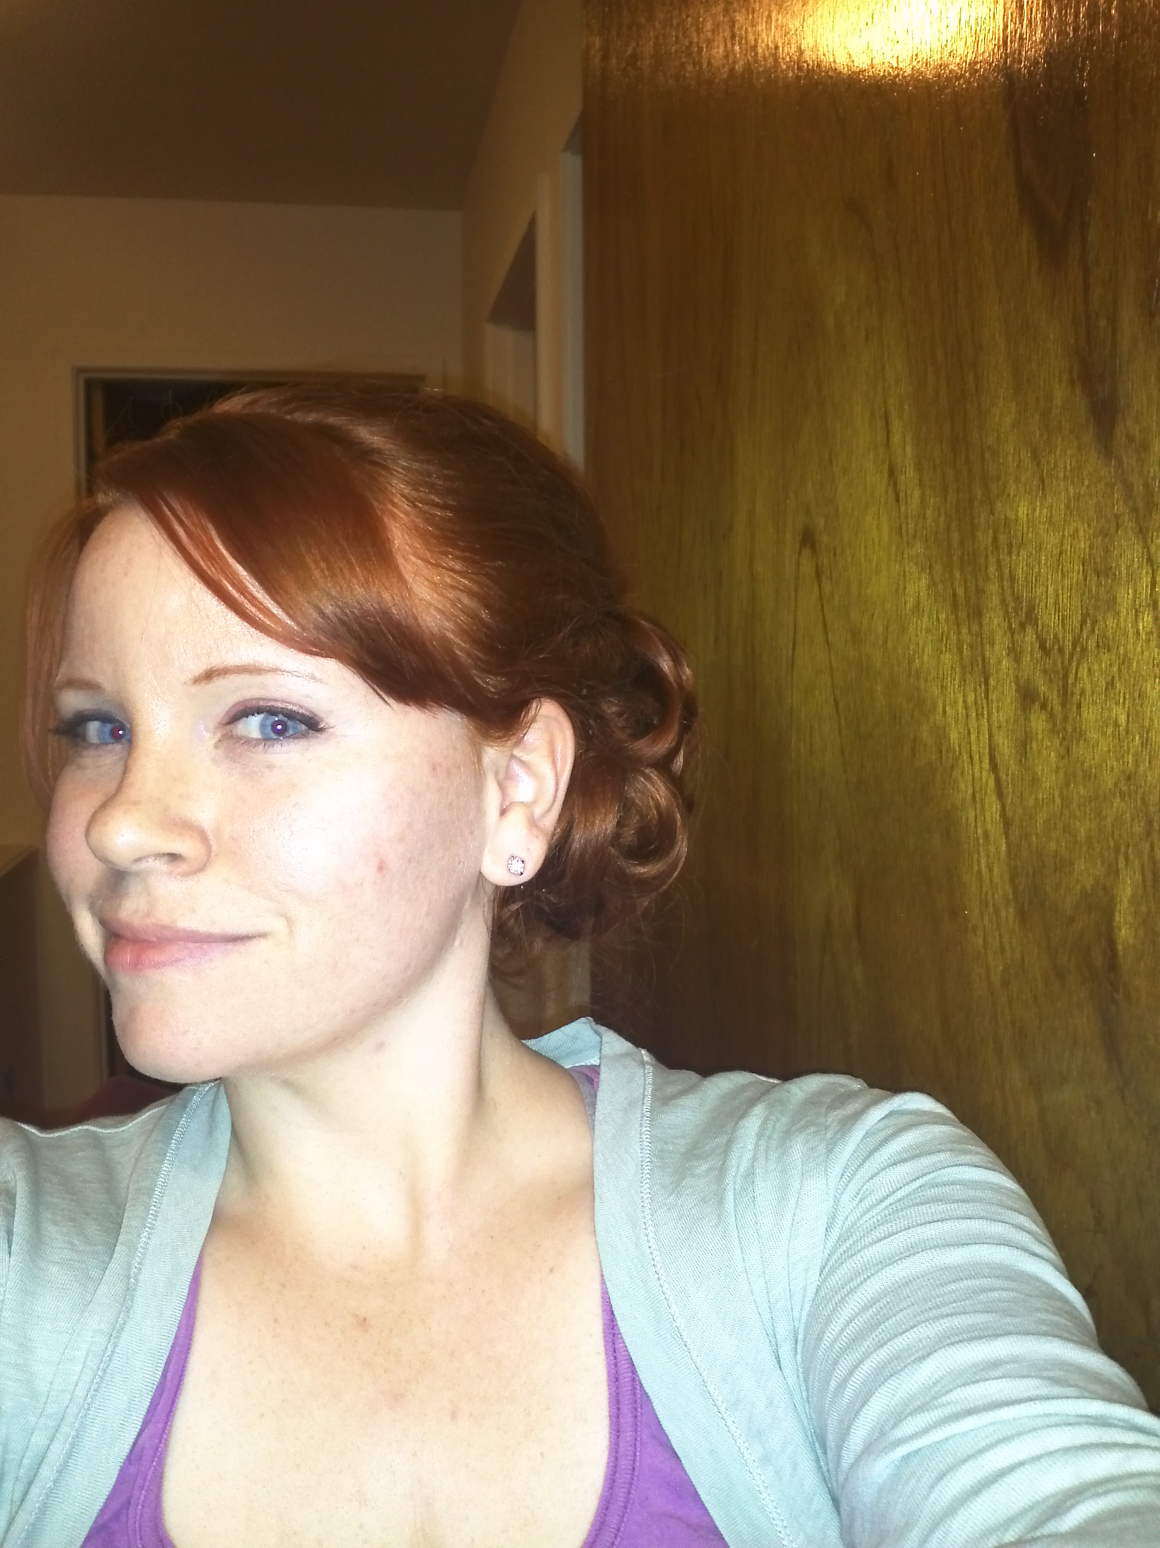

## moleskine #6

iii.

darling i need you, even though

these my words are not

as they were once,

beautiful, and even though

i am only

skin-and-bones, and even that

in daily decay, flaking

off as ash or dander: my love

is like our bodies like

the dander

in our sheets: one day after life

is ripped away like a veil to leave the sucking

sounds of detergent, thin pale

sheets of

skin or / paper-

linen will be

washed away.

away in white, the crisp-

bleach clarity of

gone-ness.

and this is my

constant reflection: i

who will live forever

am constantly given

to death:

what can our

fingers,

clasped together,

do?

what secret cache of claspings

can fingers brace

against dust?

there is some

secret

here

between

our rustling:

i speak

in a mystery of

the Christ

and his bride the New

Jerusalem.

what is *my* bride, then,

when one day i will know her

no more? is this vain

clasping just

a metaphor?

touch

breathe

heat between

these sheets, these linen

words that do not

keep. inside your

metaphors i

sleep.

who will shelter me

from the wind

when your body is wind?

when mine

a breeze?

who will lie with me

between these sheets

once the sheets are clean?

what kind of metaphor

is dander? and what

do fingers mean?

is there some secret

meaning of death?

is the afterlife

an interpretation?

what does it mean,

O Metaphor Logos, that you

became fingers, and teeth, and skin?

is the Spirit a bone or a tooth?

father my whole

self draws back

from You--You corrupt

my hermeneutics. you deny

my every reading.

my words don't do

no good--my skin

and teeth

no better.

but something in me nonetheless claws

+ pants + strains, some

something in me

needs.

*

Spencer, don't you understand? My God is the only god who has died--who knows what it's like to feel loss--who's been beaten and whipped and forgotten. who knows what it's like to live inside this body that turns to dust in the space of a day.

to feel shame and regret and loss and hunger; who's lost all the lost children of all the lost mothers in time; who's been forgotten and abused and murdered.

my god is the only god for whom this / broken world has sometimes / not made sense.

he knows that. he's felt that. he is the only one who has died.

and then inside that, inside this brokenness, this slavering darkness glowering over the cradle--this stupid body--inside all that, my god has loved w/ a love like a tiny candle--a little flame that just burns and burns until it swallows the darkness with its flicker.

my god knows what it means to die and live.

there's no one like that. who knows my every brokenness and triumph.